**Task4**

Develop the queries to retrieve information from the OLAP operations performed and to gain a deeper understanding of the sales data through different dimensions, aggregations, and filters.

**Project: OLAP Operations (using SQL)**

**Objective:** Perform OLAP operations (Drill Down, Rollup, Cube, Slice, and Dice) on the "sales_sample" table to analyze sales data.

**1.Database Creation**

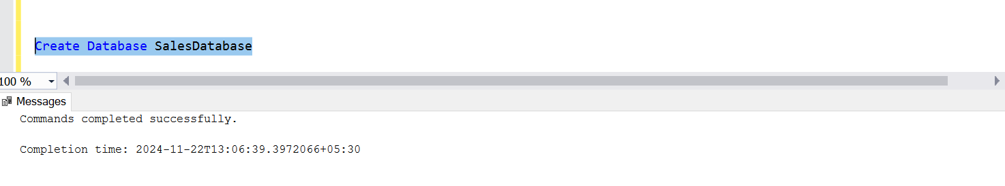

**Table Creation**

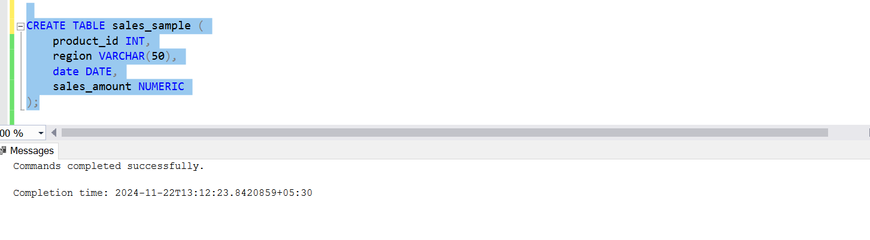

**2. Data Creation**

Insert 10 sample records into the "sales_sample" table, representing sales data.

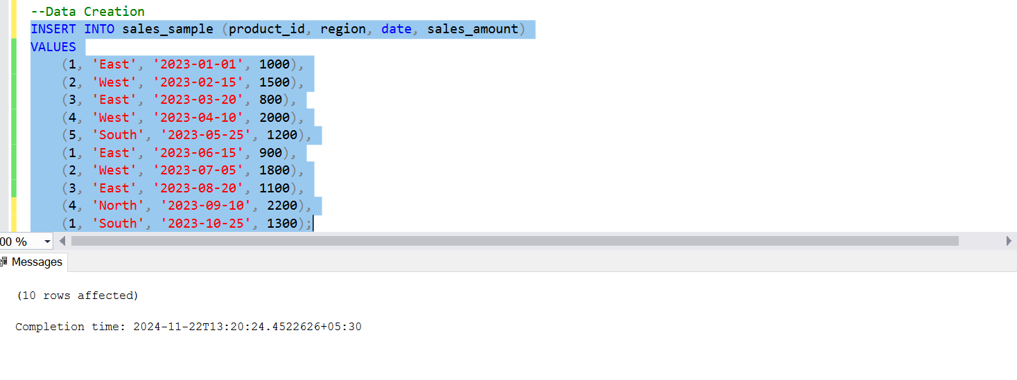

**Table sale_sample**

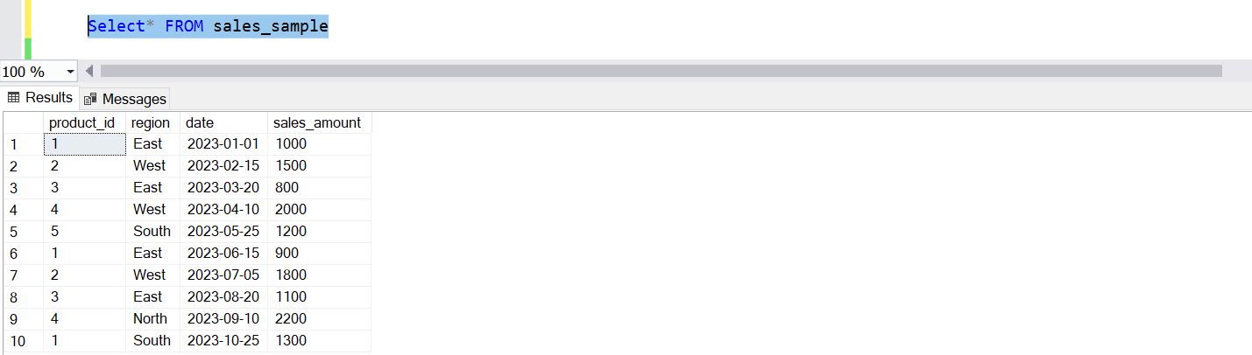

**3. Perform OLAP operations**

a) Drill Down-Analyze sales data at a more detailed level. Performed drill down from region to product level to understand sales performance.

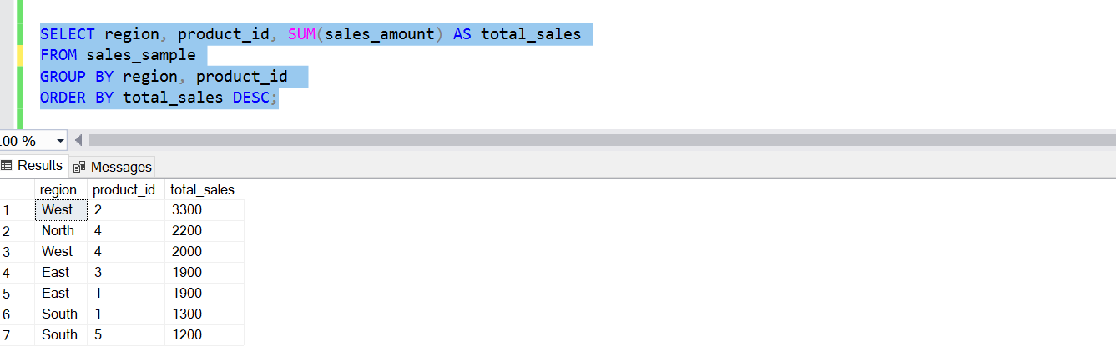b) Rollup- To summarize sales data at different levels of granularity. Performed roll up from product to region level to view total sales by region

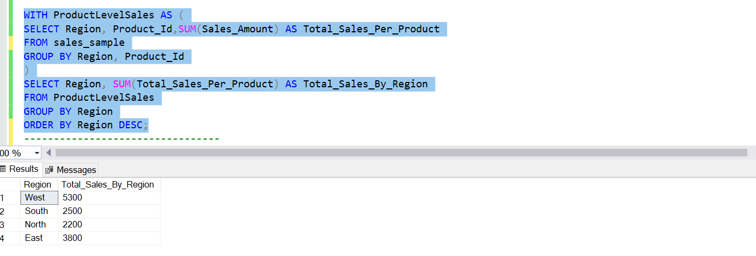

c) Cube - To analyze sales data from multiple dimensions simultaneously. Explore sales data from different perspectives, such as product, region, and date.

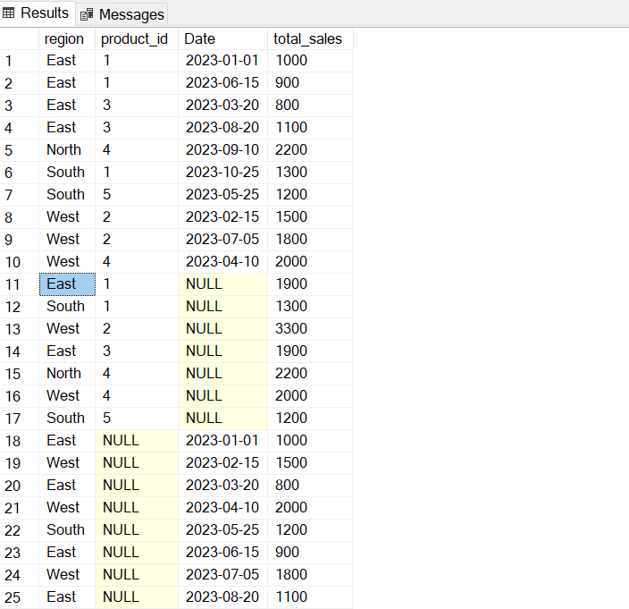

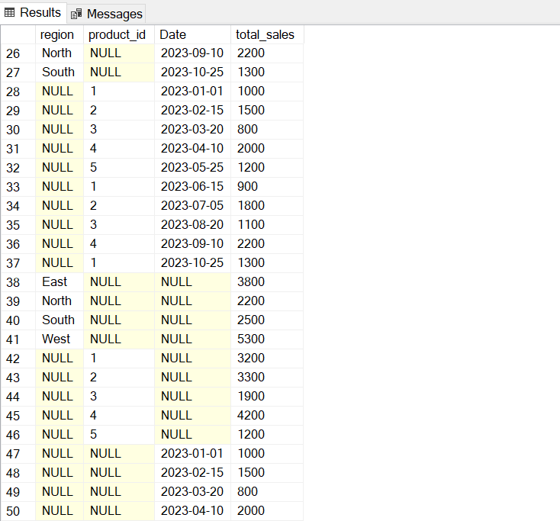

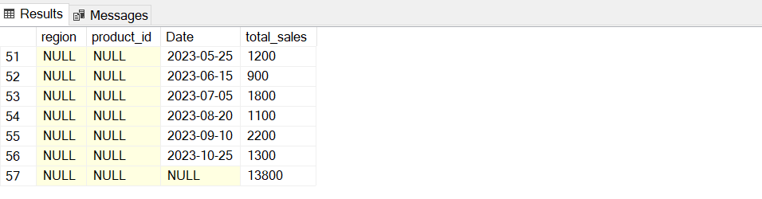

d) Slice- To extract a subset of data based on specific criteria. Write a query to slice the data to view sales for a particular region or date range.

**Sales for a specific region (e.g., 'East')**

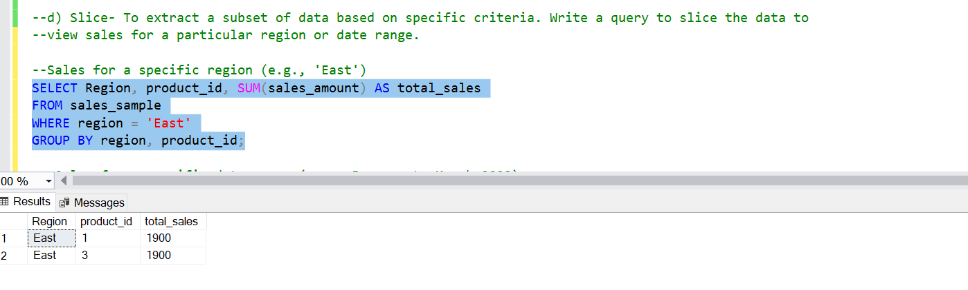

**Sales for a specific date range (e.g., January to October 2023)**

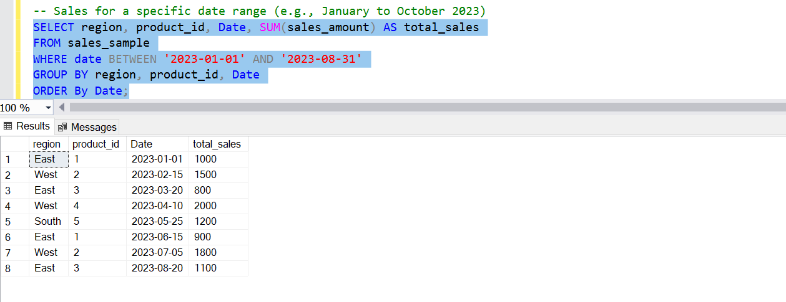

**Sales for a specific region and date range (e.g., January to October 2023)**

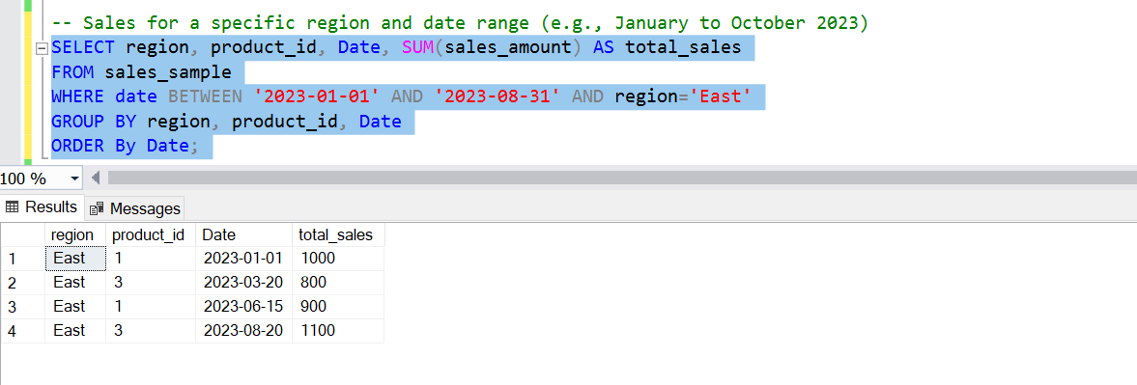

e) Dice - To extract data based on multiple criteria. Write a query to view sales for specific combinations of product, region, and date

**Sales for a specific region and product (e.g., 'East' & 'West' and product ID 1)**

